**DOCKER INSTALLATIONS**

1.first create an aws instance and open the instance

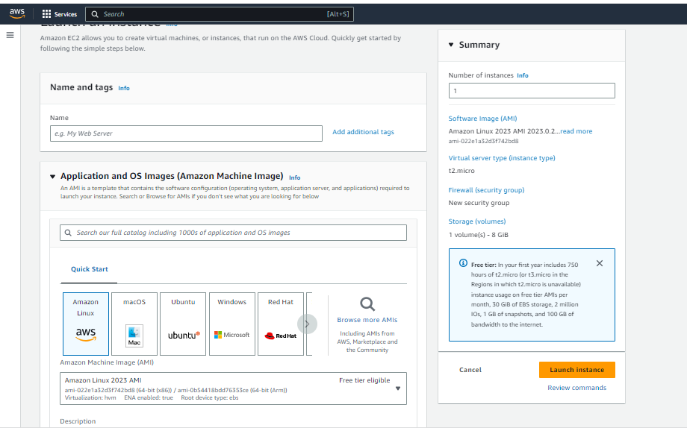

Running instance

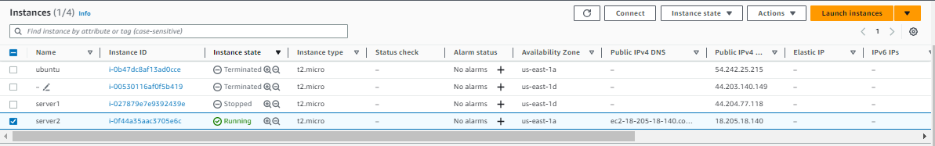

Connected to ec2 instance

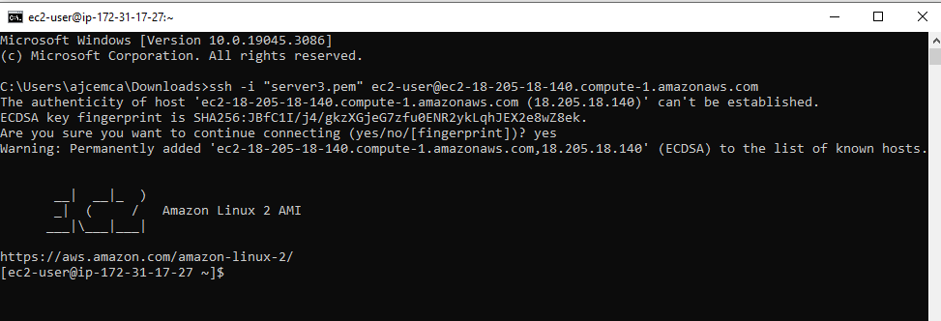

2.update the system and checking if any docker exist

**#yum install update -y**

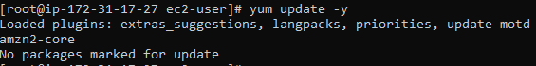

**#which docker**

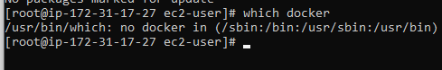

3. installing docker to the instance

**#yum install docker –y**

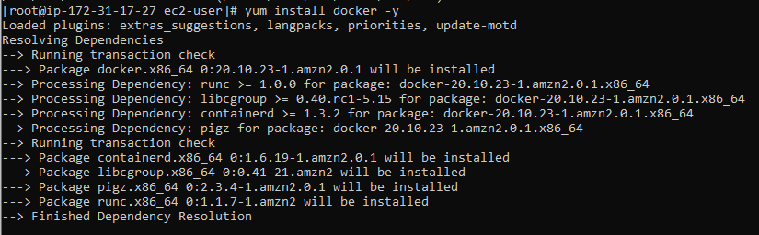

4.checking the version and information of the docker we installed

**#docker --version**



**#docker info**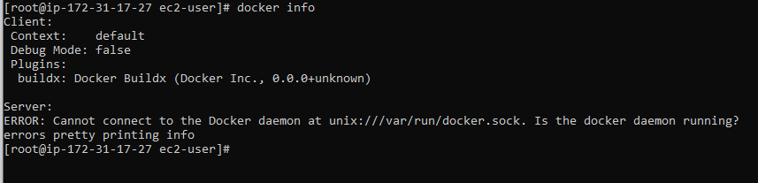

5. Checking the status of the docker and starting the server

**#service docker status**

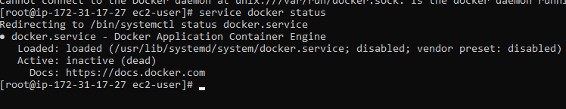

**#service docker start**

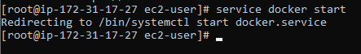

6.listing docker images

**#docker images**



7. Check if any process running

#**docker ps**

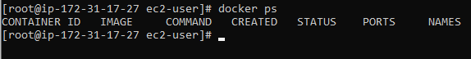

All processes

#**docker ps –a**

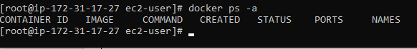

8. Pulling a docker image of any OS from the docker hub

#**docker pull <image name>**

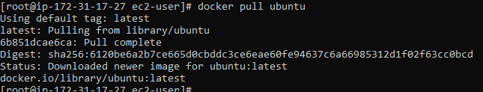

9. now again list docker images

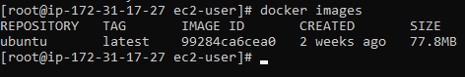

**See we have a new docker image here**

10. running the docker image

**#docker run –it Ubuntu /bin/bash**

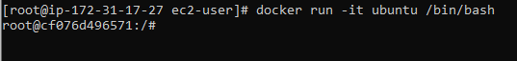

**11.** custom naming a docker image

**#docker run –it –name <name> Ubuntu /bin/bash**

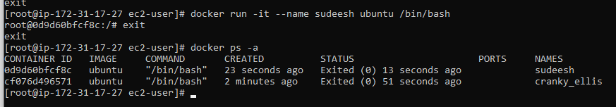

12. Installing a image without pulling it initially

**#docker run –it –name <name> <OS_name> /bin/bash**

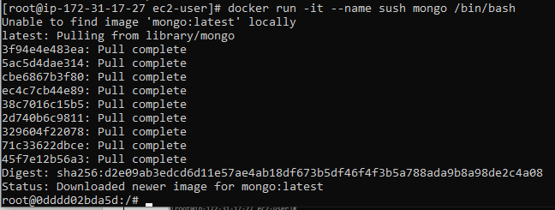

**13.** To start a docker

**#docker start <dockerimage_name>**



**14.** To enter into the docker image

**#docker attach <docker_name>**



**15.** create and view a file in the docker

**#cat > file.txt**

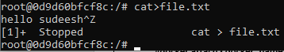

View file

**#cat file.txt**

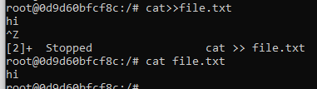

Listing all the files in docker image

**#ls**

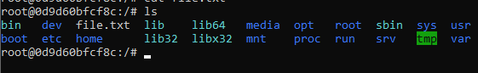

16. installing apache2 on the docker

**#apt-get update**

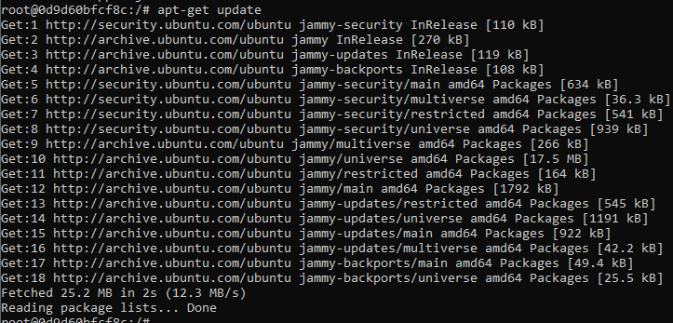

#**apt-get install apache2 -y**



